System Design Document
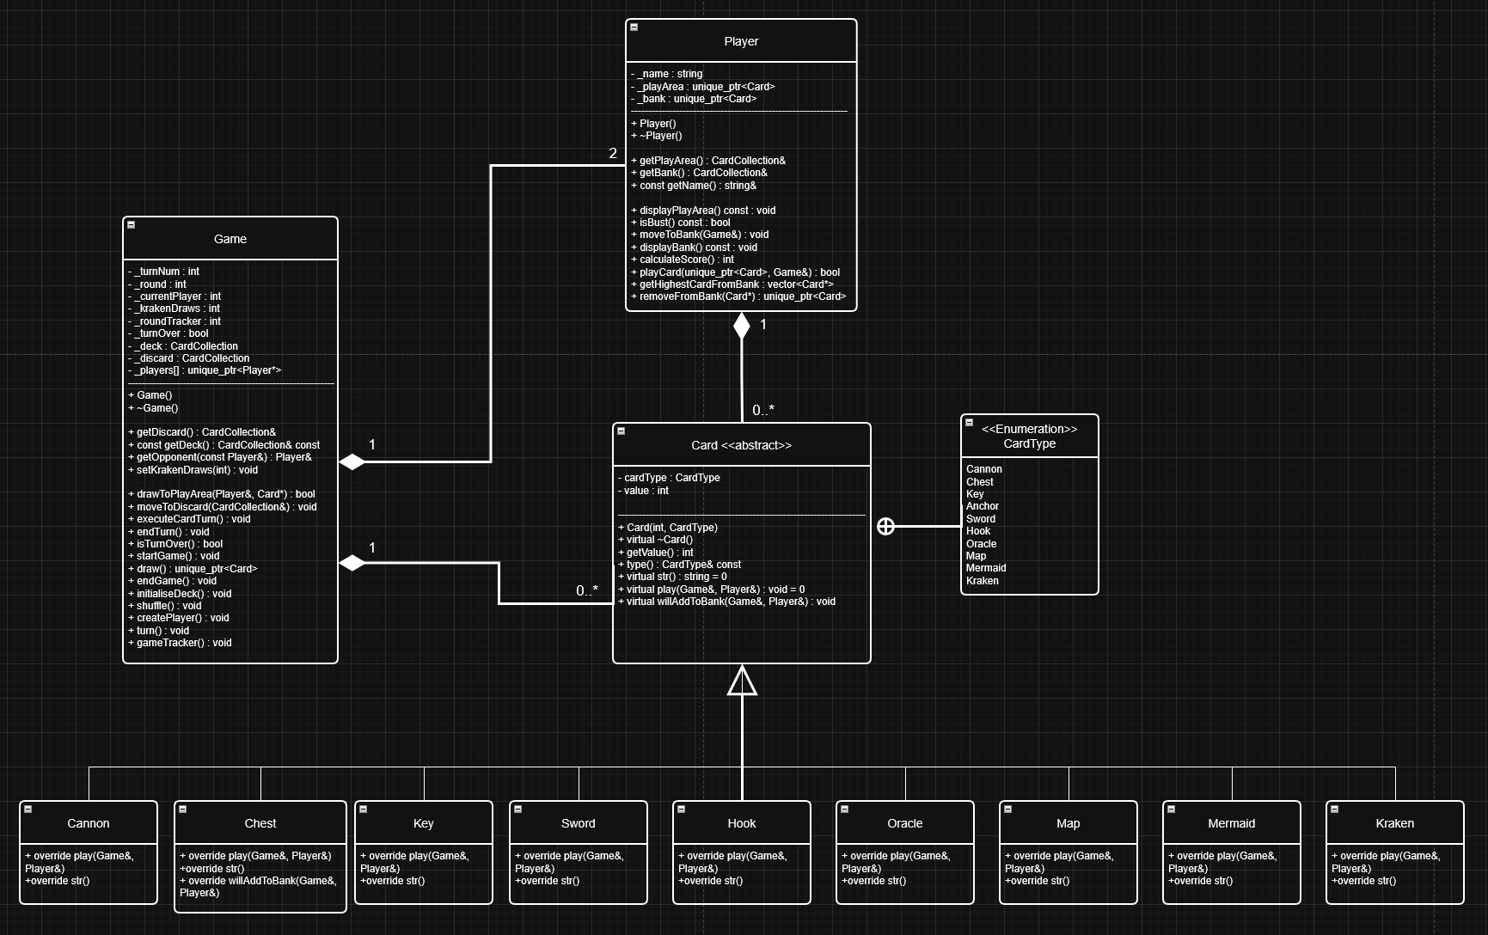
Class Diagram

How the Design Constraints Were Met:
DC1:
- A Game, Player, Card, and Card Abstract classes were implemented
DC2:
- The game compiles, executes and runs as expected with no errors
DC3:
- std::map was used to map cardtypes (suits) with their values and was used for grouping suits and displaying cards in the bank, tracking the highest cards to calculate the score, and getting the top value cards from an opponent’s bank
- std::set was implemented to check if the player is going to bust by first adding a card to the player’s current play area and then creating a set and checking if any duplicates occur (since sets can’t hold duplicates). This is more efficient (O(n)) than iterating through an array in O(n²) average time.
- std::vector was used to hold the collection of cards in the deck, discard, play area, and bank
- Arrays were used by fixing the number of player names to be randomly chosen from and to fix the number of players in the game.
DC4:
- Unique pointers were used to reference each created card and player
- References to objects through functions were used throughout the entire project
- Utilised std::move and .get() functionality for unique pointers
DC5:
- Since unique pointers delete when they go out of scope, there wasn’t any need for manual pointer deletion and thus there should not be any memory leaks
DC6:
- See above
DC7:
- Most getter functions were declared const, except for getDiscard(), getBank(), and getPlayArea(), since they were used and modified through card abilities like Map and Chest
- Any method that did not modify any data was declared const, such as displayBank/PlayArea(), and isBust().
DC8:
- Initialiser lists were used in the Game and Card constructor to initialise all member variables
DC9:
- All formatting rules were followed
- All header files implemented #ifndef, #define, and #endif
- All argument names are informative
- Naming conventions were followed
- Underscore was used for private member variables
- An enum class was used to define the card types
- The class methods have made use of private access sections so that the main file only needs a game object and the startGame() method. Methods that do not need to be public are private.

DC10:
- No external libraries were used

Other Design Implementation Choices

- The discard pile acts as a stack, so cards that are discarded will appear in the same order when an ability that sees the discard pile is used (Map for instance)
- For the Kraken ability, added a separate draw loop within the turn function in Game using an int krakenDraws variable to prevent duplicating the same code in the Kraken class
- The WillAddToBank function in Card is overridden in the Chest class with the Chest/Key ability functionality, so that ability is only run from one class to prevent duplication
- Though not specifically stated in the assignment spec, input handling is implemented so that no crashes/errors occur, and will continually ask the player to input again until it is correct

Flowchart of Gameplay Loop
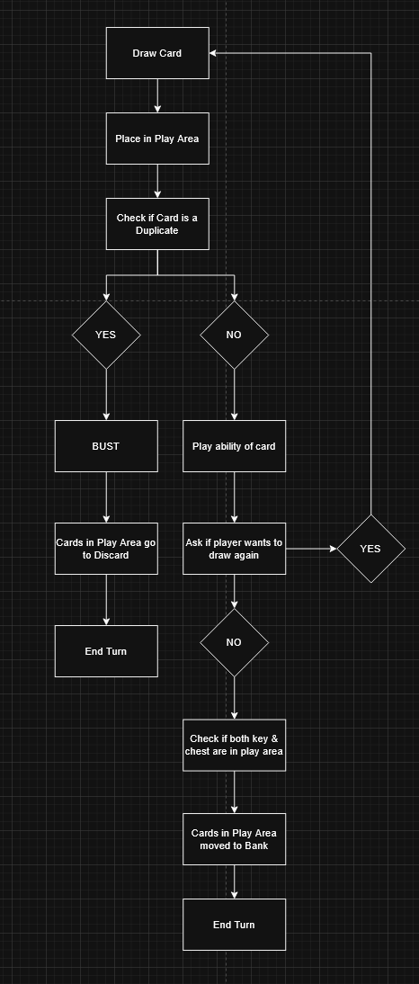
- Flow of the gameplay to provide visualisation to what is occurring, and shows the order of actions

